ASSIGNMENT 2
First Year
QUESTION 1:
For a molecule with more than one conformer, the conformers lie at the minima of the energy vs dihedral angle diagram (statement A) and interconversion of various conformers needs bond breakage (statement B)
- Statement A and B are both correct
- Statement A is correct but statement B is wrong Ans b: Conformers are interconvertible by rotation
c) Statement A is wrong but statement B is correct
QUESTION 2:
For cyclohexane C₆H₁₂, the twist boat form is less stable than the boat form.
- True Ans: b Twist boat is more stable mainly because of less flagpole interactions
- False
QUESTION 3:
Heat of combustion per methylene follows the order:
- Cyclopropane>cyclobutane>n-butane Ans: a
- Cyclobutane>cyclopropane>n-butane
- n-Butane>cyclobutane>cyclopropane
- Cyclopropane>n-butane>cyclobutane

QUESTION 4:
Which of the following represents is meso-tartaric acid
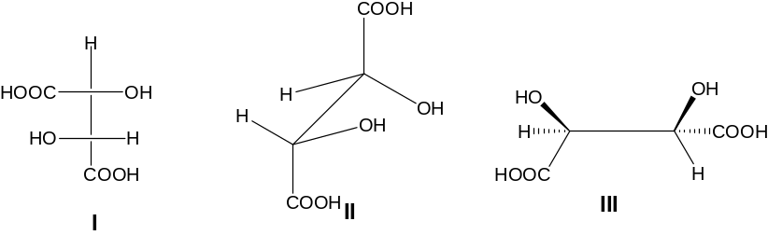

- I
- II
- III
Ans a.
QUESTION 5:
The number of gauche butane interaction(s) in the most stable conformation of 2,3-dimethyl butane is
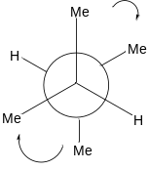
- 1
- 2
- 3
- 4
QUESTION 6:
The excess energy that the following conformation has over most stable conformer of n-butane is (one gauche butane interaction energy is 0.9 kcal/mol)
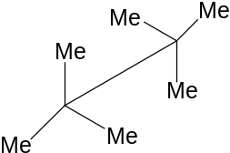

- 0.9 kcal/mol
- 1.8 kcal/mol
- 3.6 kcal/mol
- 5.4 kcal/mol Ans: d

QUESTION 7:
The correct order of ease of stretching of “C=O” bond in the following molecules is
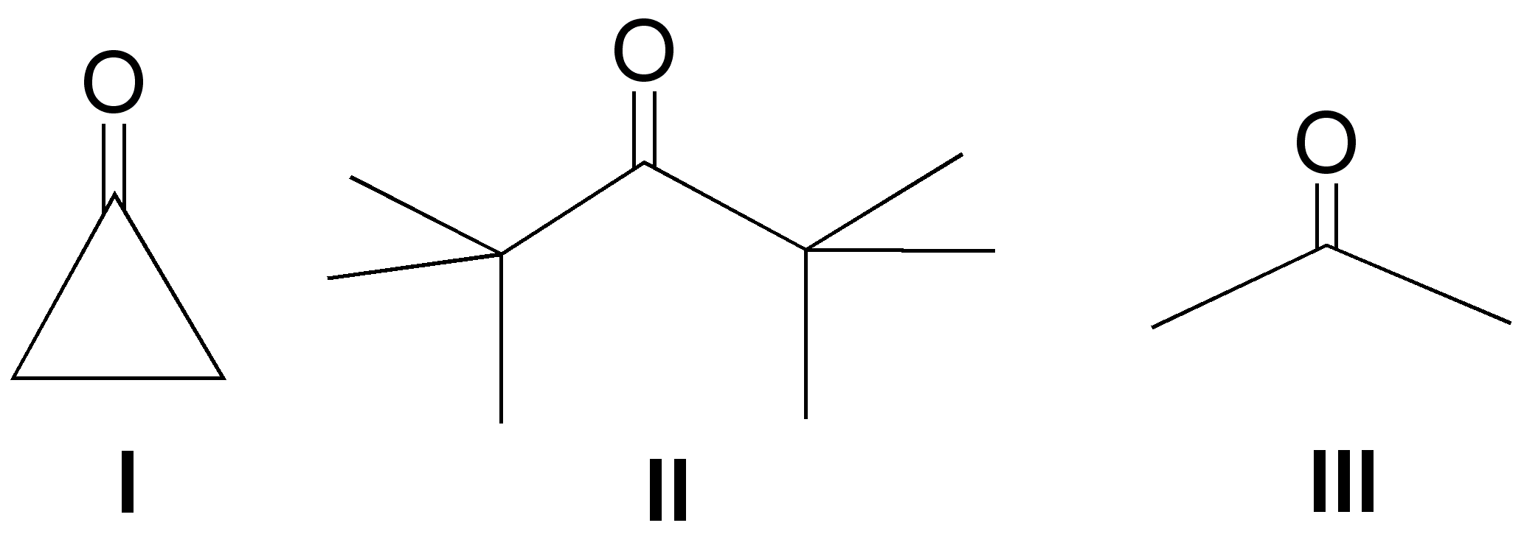% of s character varies as: I>III>II
Ease of stretching II>III>I
Ans: c
- I > II > III
- II > I > III
- II > III > I
- III>II>I
UESTION 8:
In the preferred conformation of X
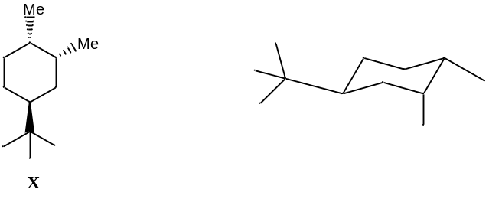

- Both the methyl groups are equatorial
- Only one methyl group equatorial Ans: b
- Both the methyl groups are axial
==================================================================================

